**Custom Training – September 26, 2023**

**Databricks Day 01**

1. **Databricks Deployment**

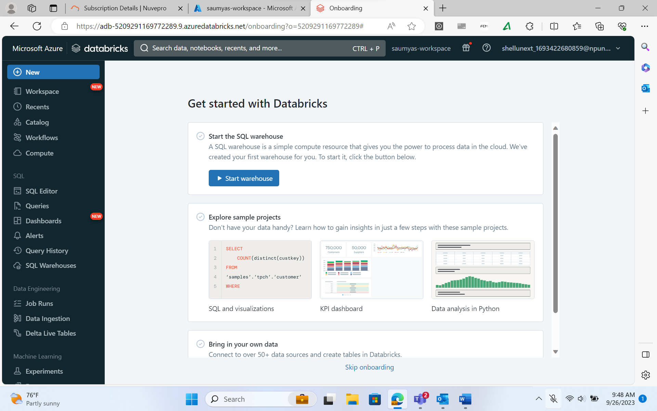

1. **Creating a cluster**

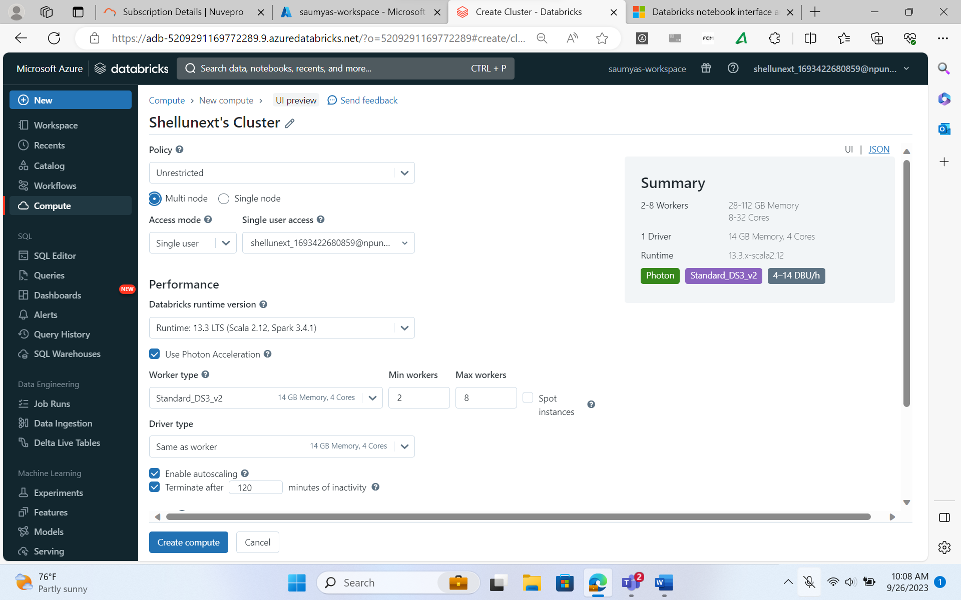

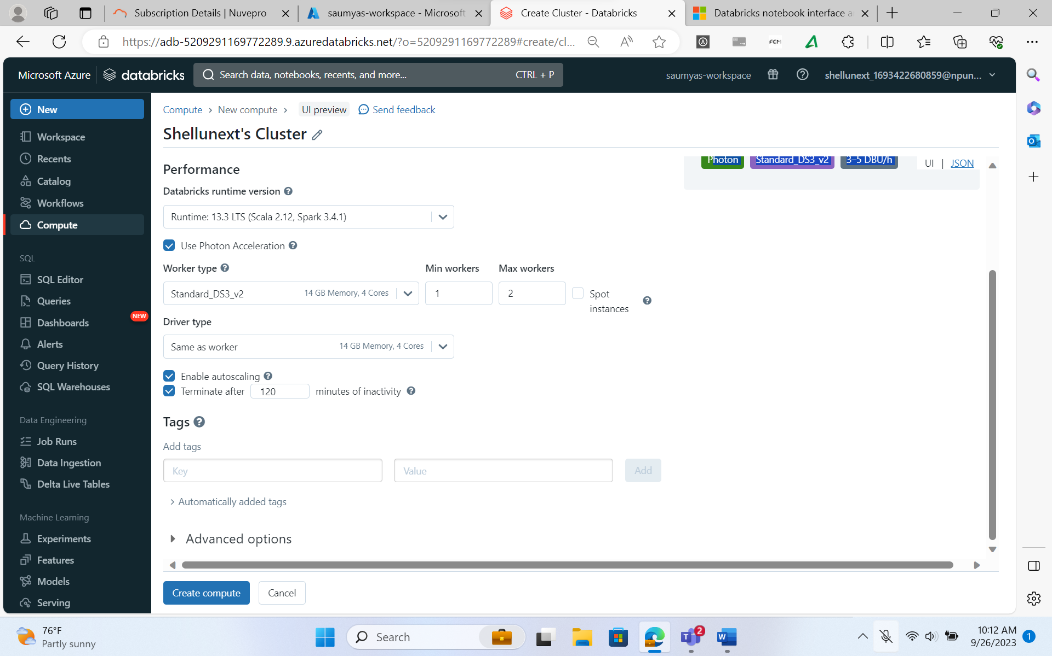

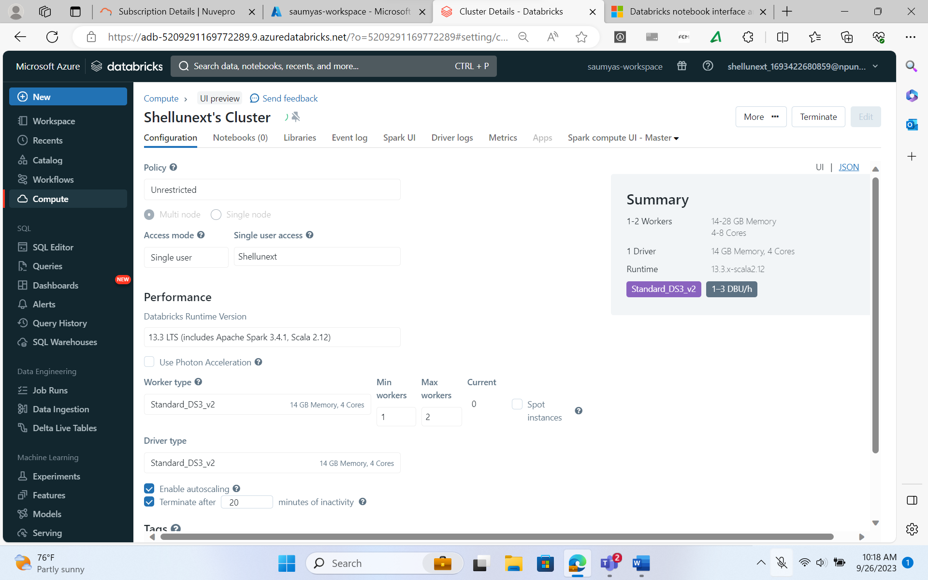

1. **Creating a folder and a Notebook inside the workspace**

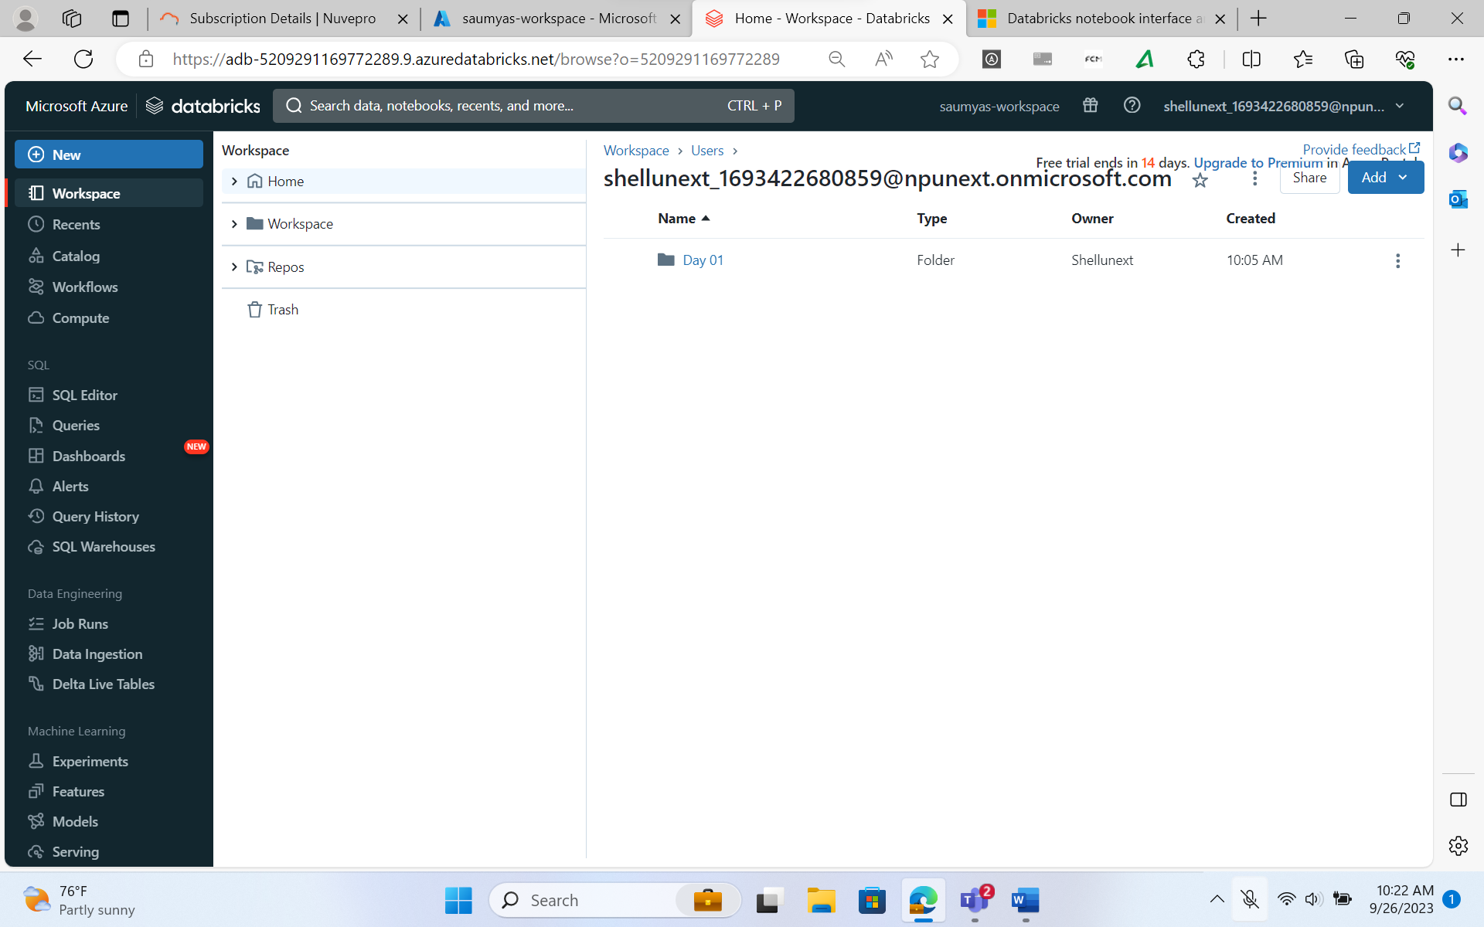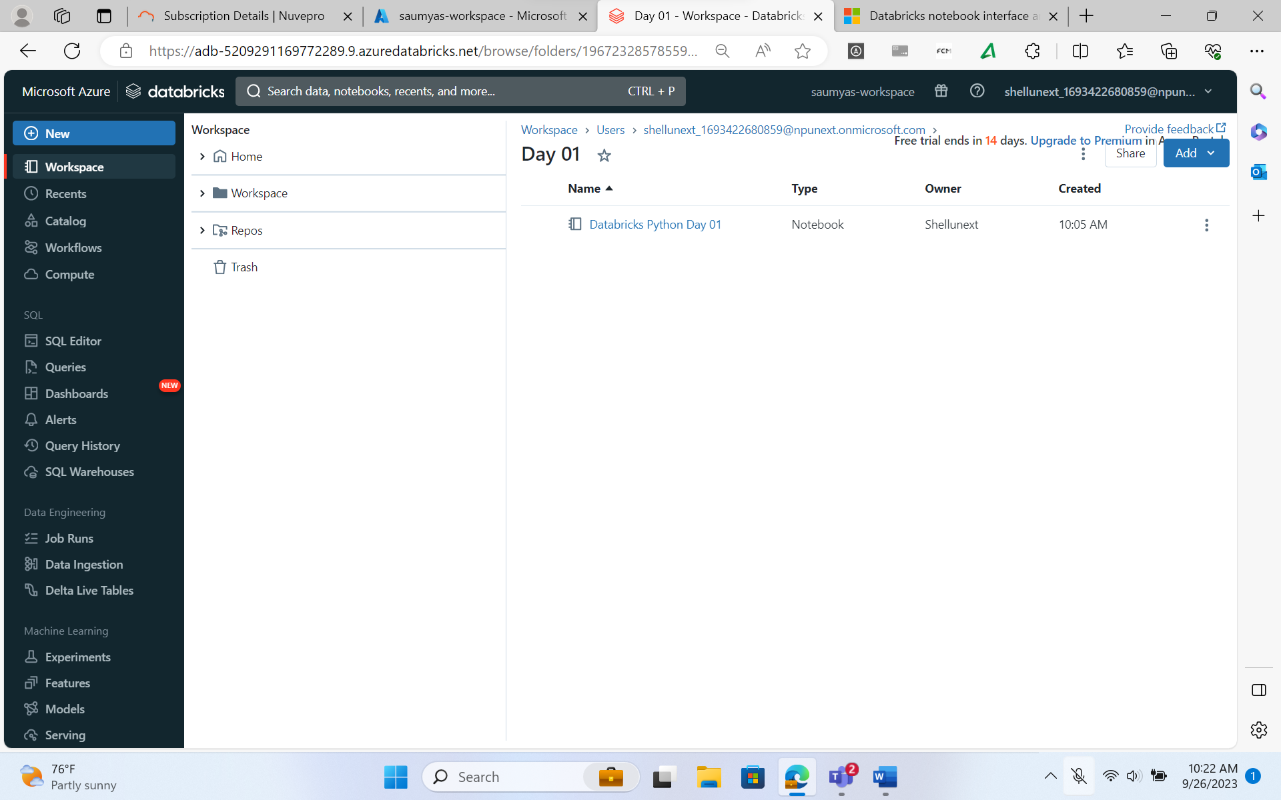

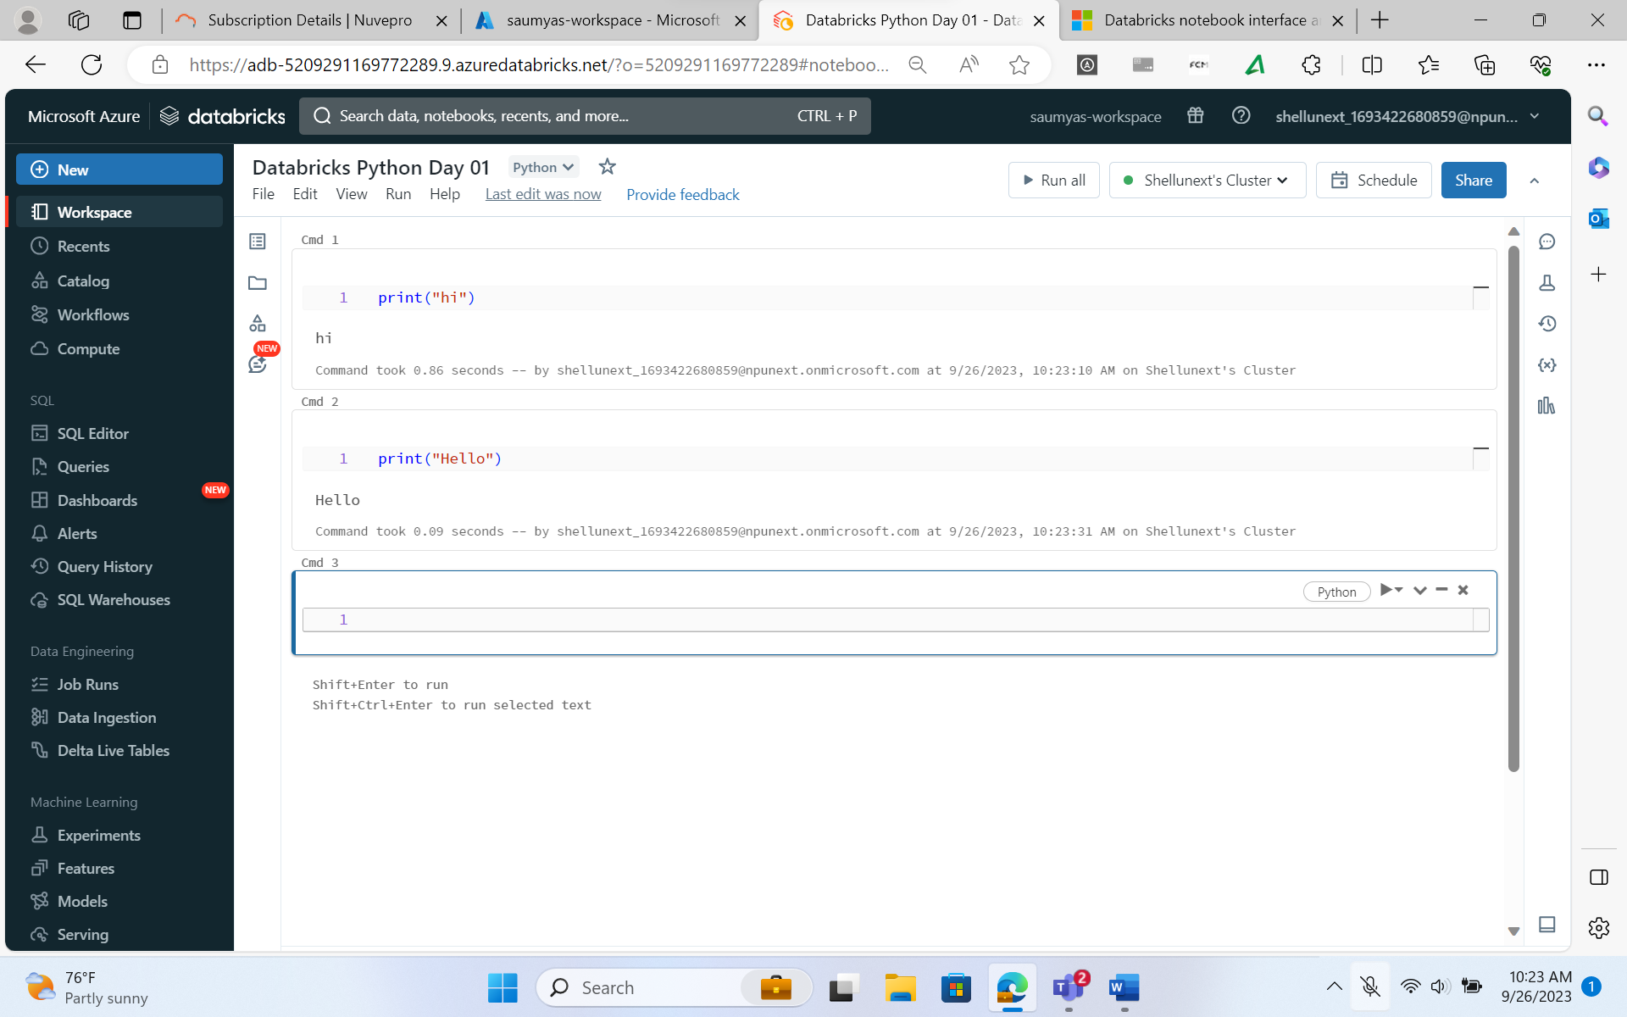

1. **Magic Command: Change the language in a cell.**

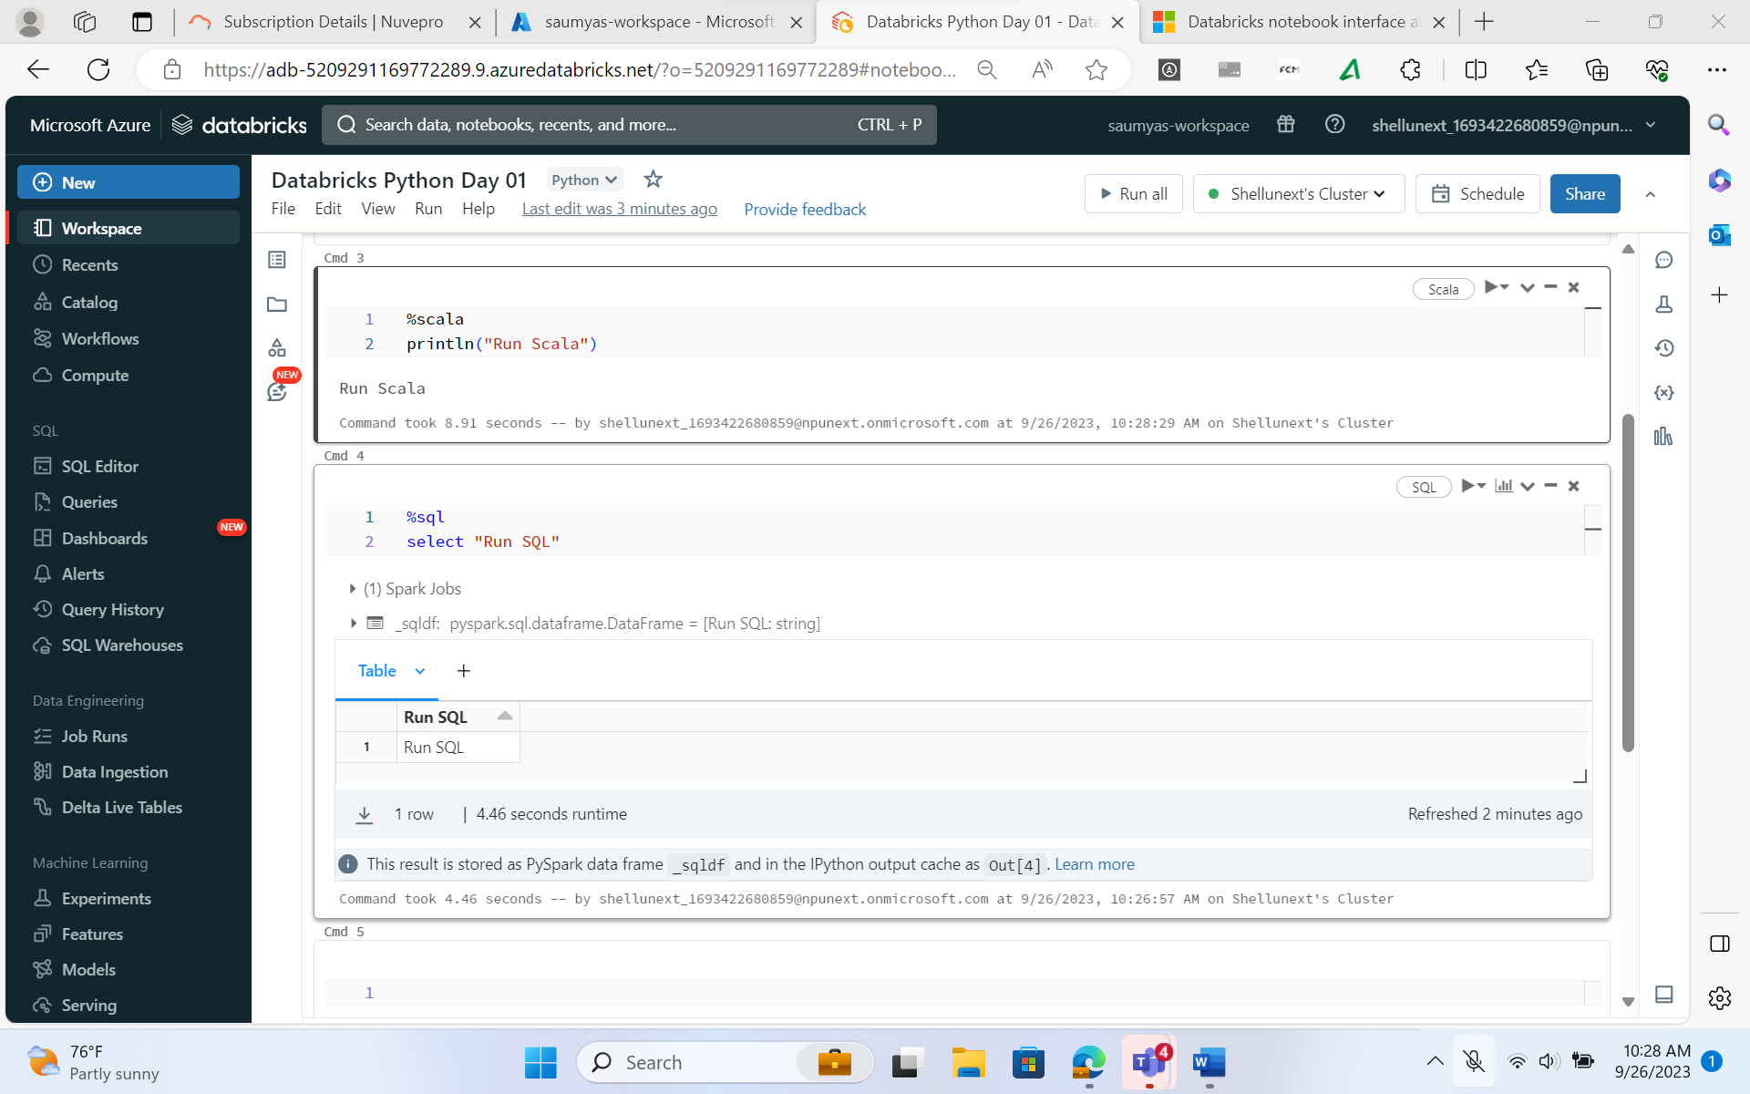

1. **Markdown in Databricks**

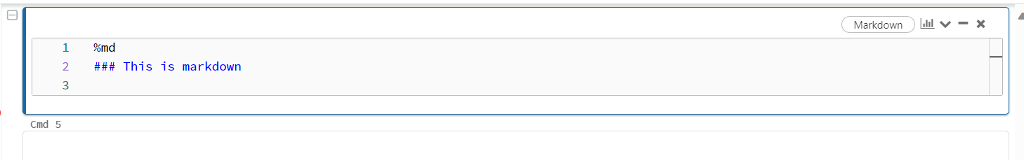

1. **Hierarchy in Databricks**

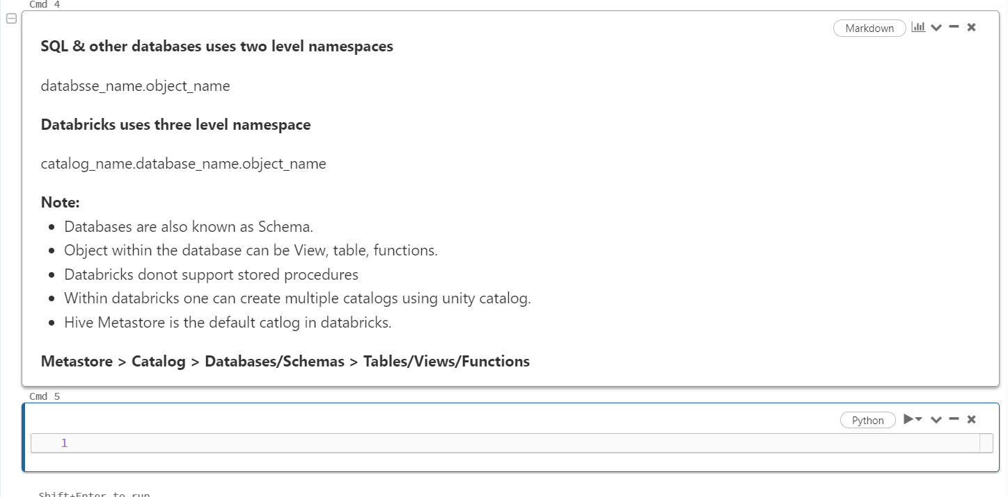

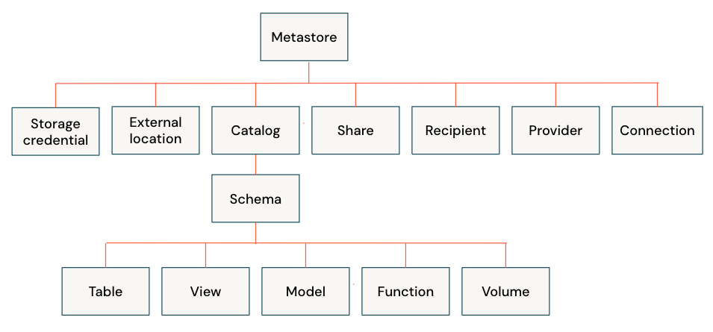

1. **Creating Databases and Tables in Databricks**

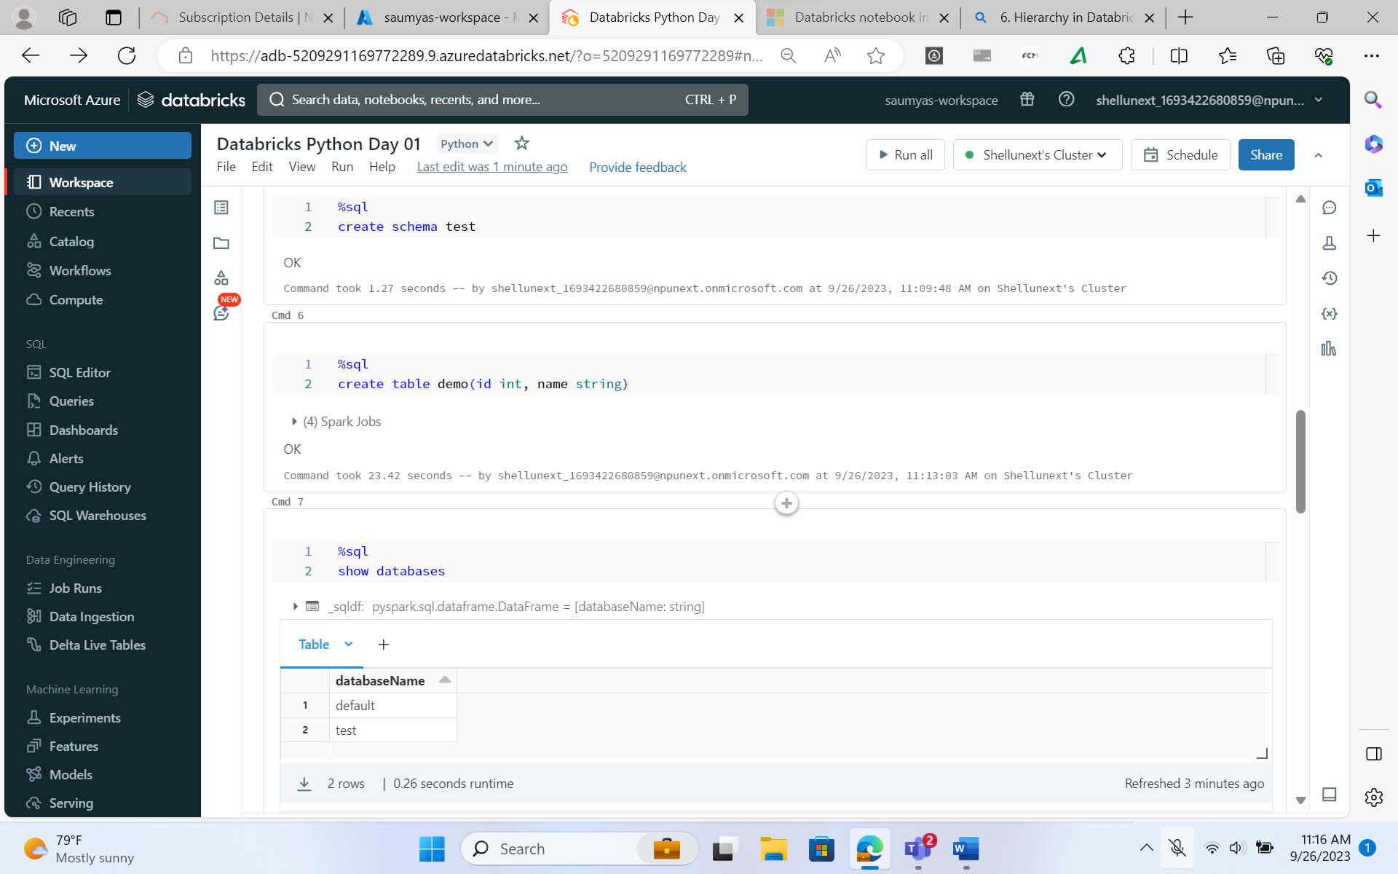

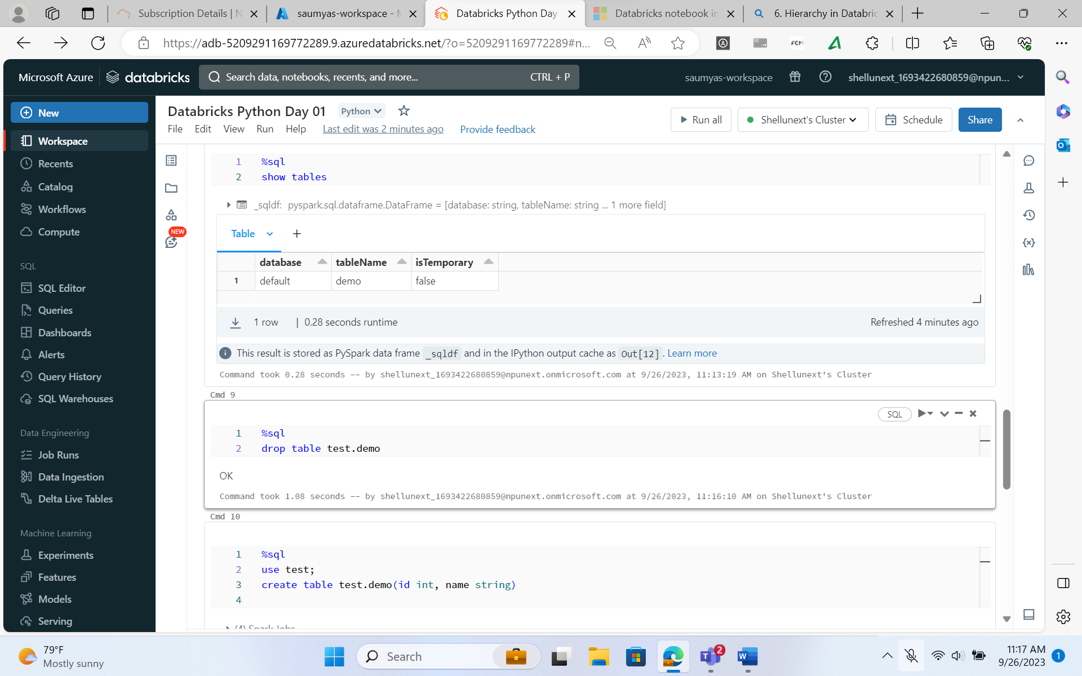

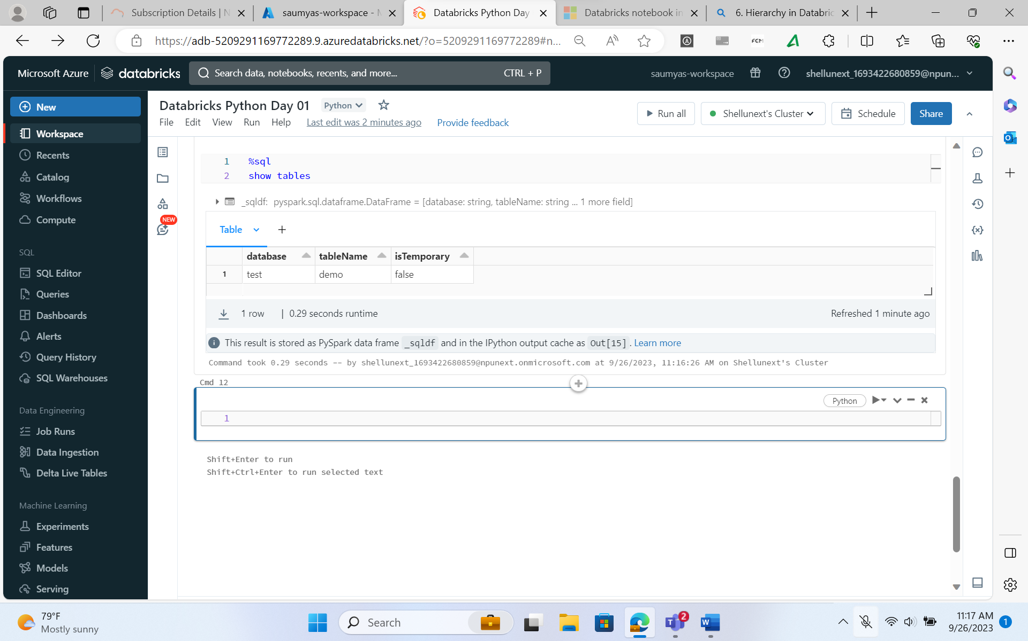

1. **Creating a DataFrame and saving it into test database**

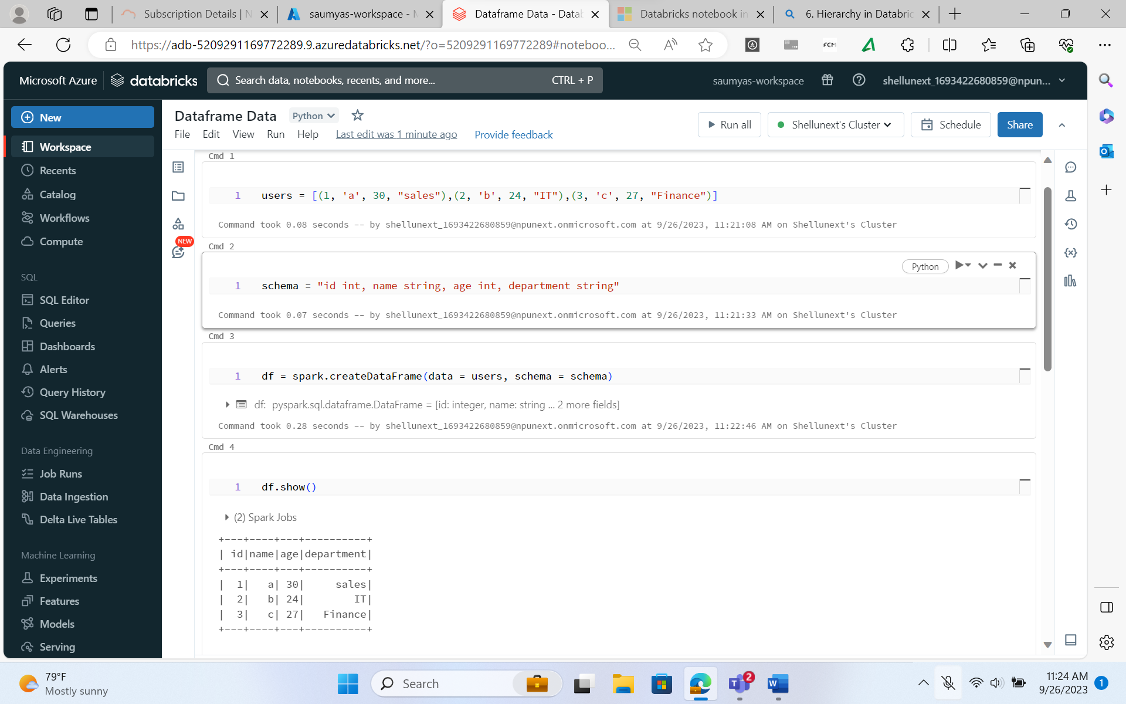

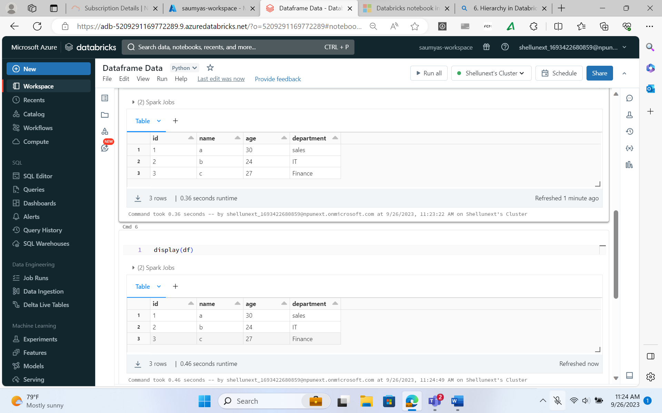

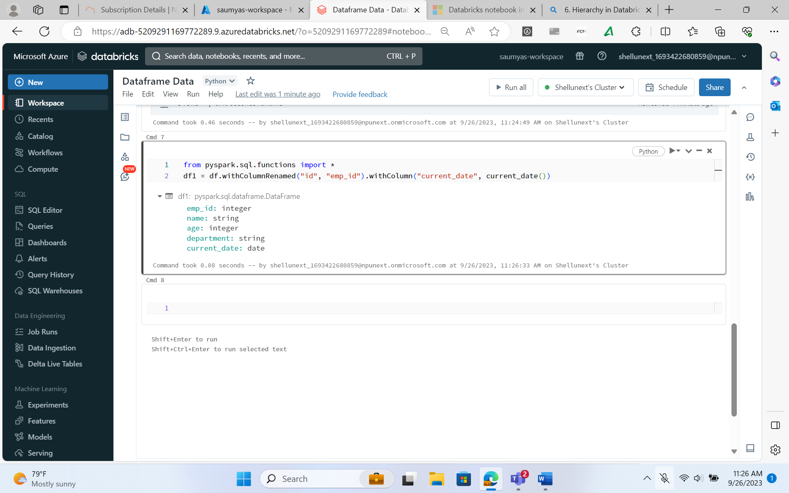

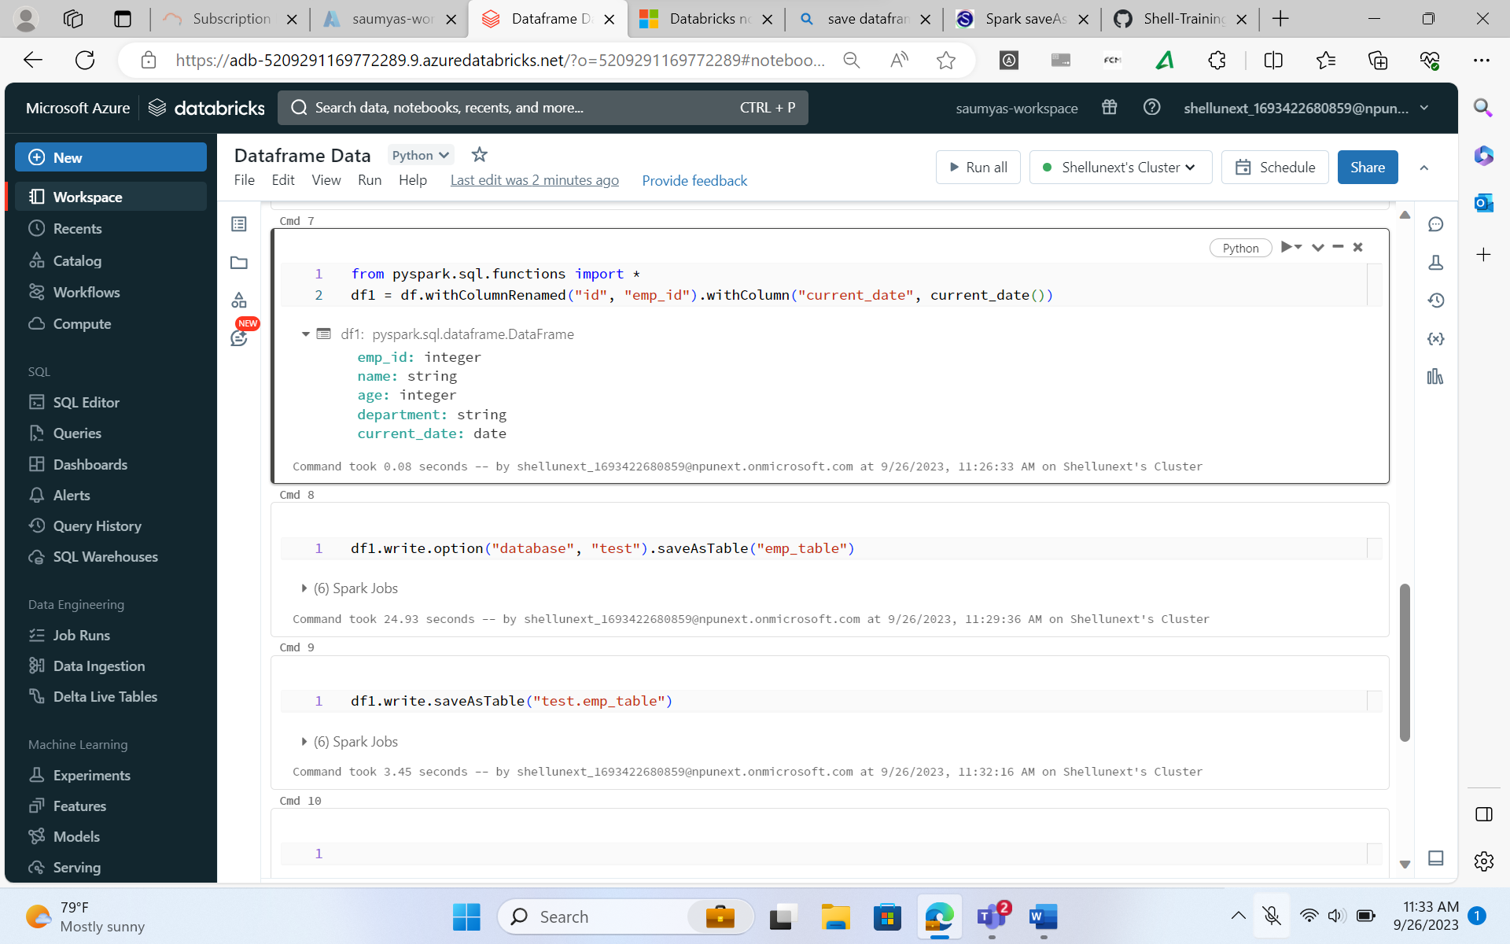

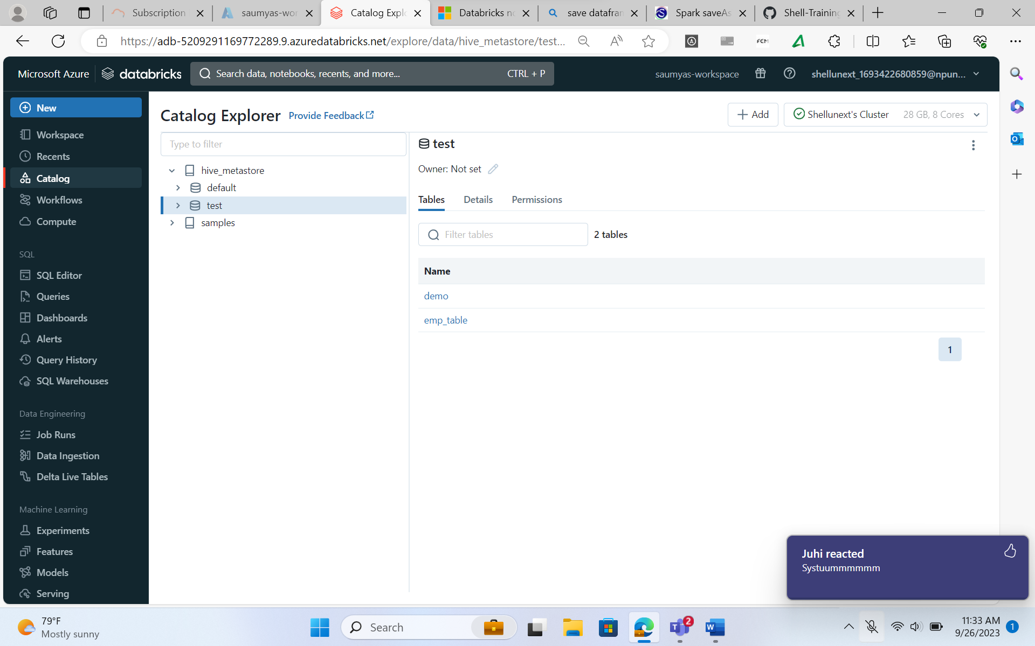

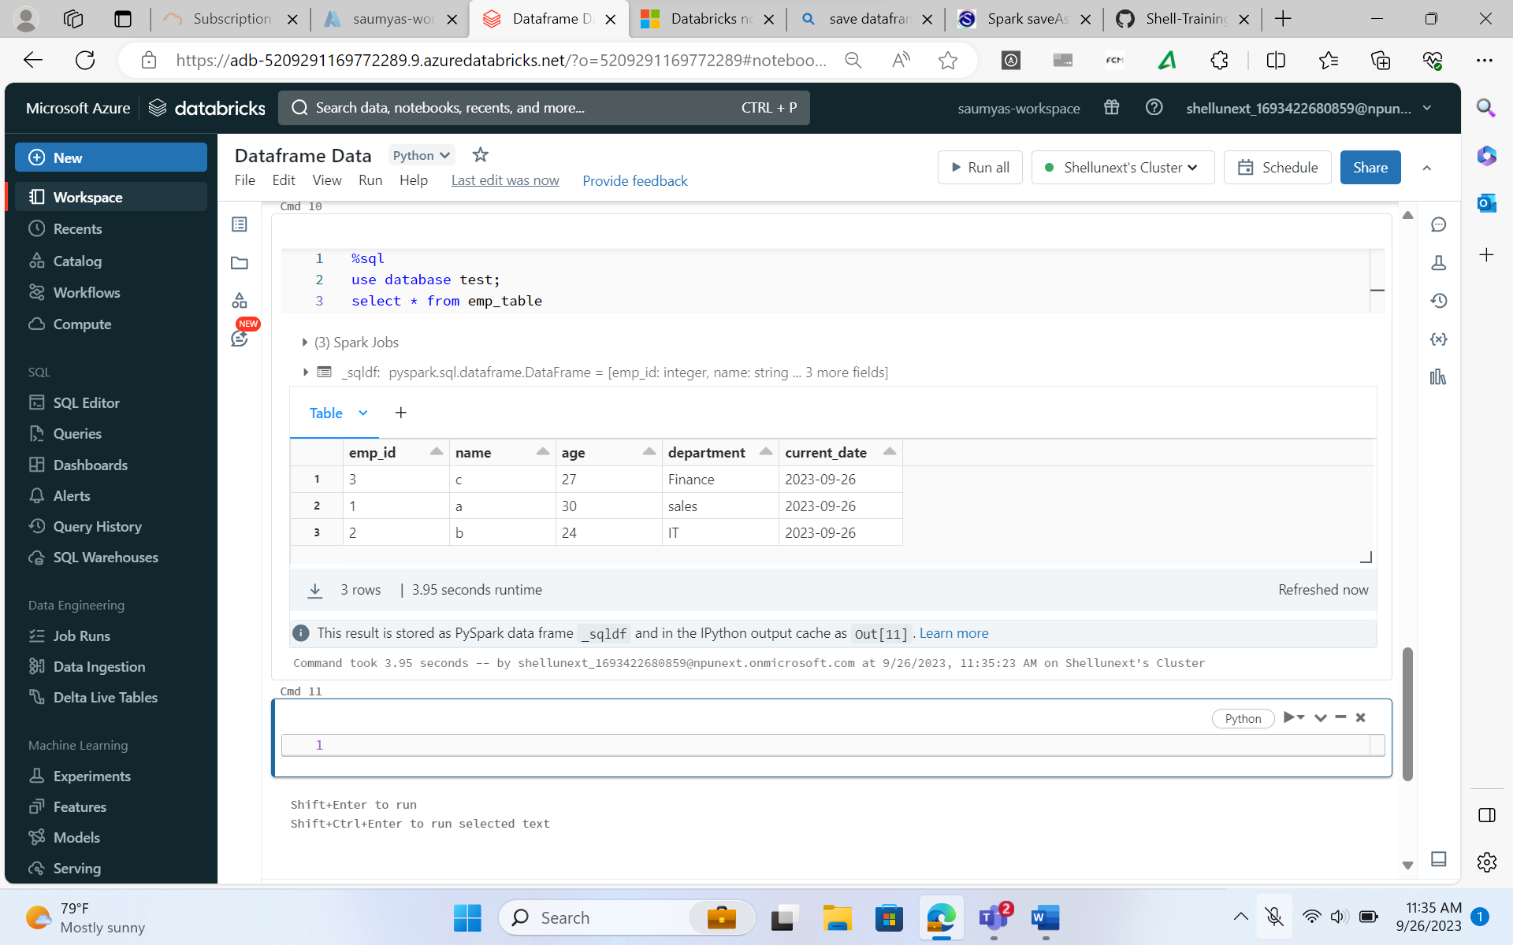

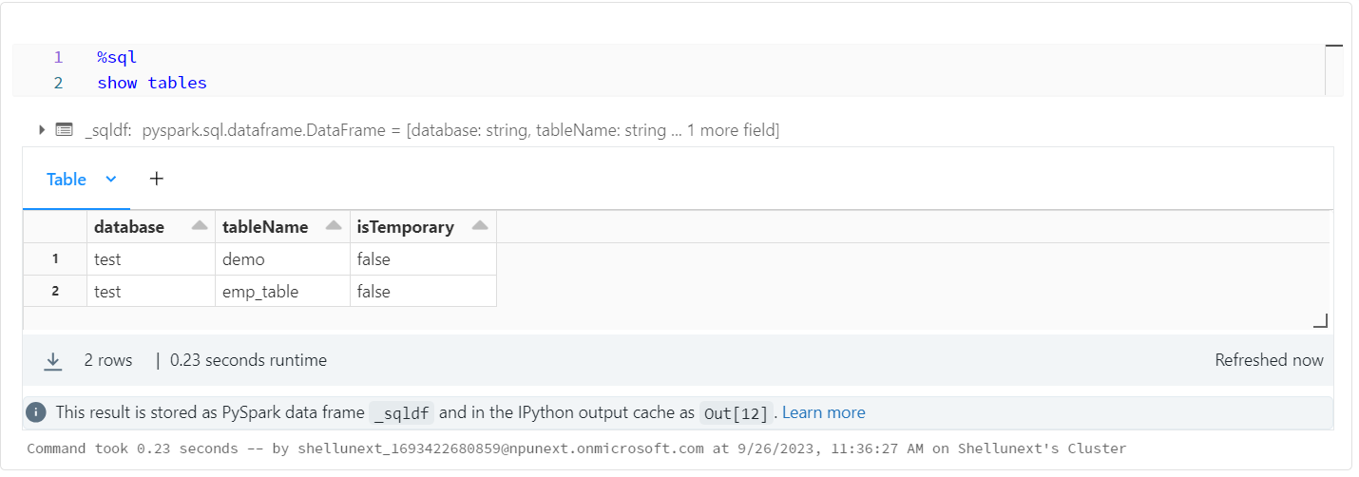

**Databricks Architecture:**

Databricks Architecture has two main components:

* **Control Plane/ Databricks Account:** Completely controlled by Databricks.
  + Web UI:
  + Workflows:
  + Cluster Management:
  + Notebook:
* **Data Plane:** It is nothing but customer cloud account. In our case it is Azure. They provide us with VMs, Clusters & Storage (Databricks File Storage (DBFS)).

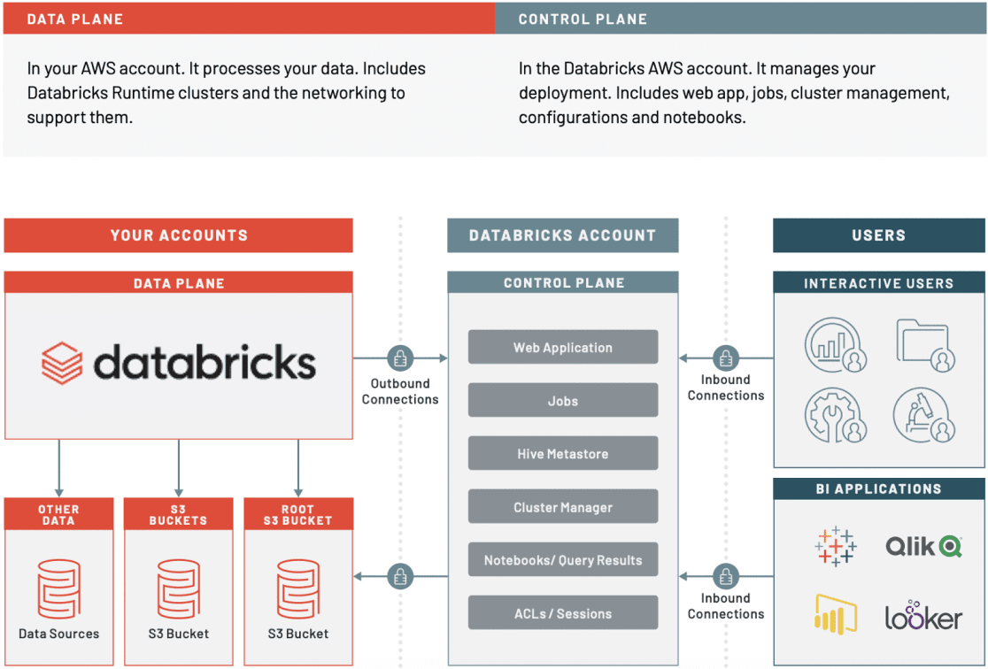

1. **Creating Table from a CSV file uploaded in DBFS**

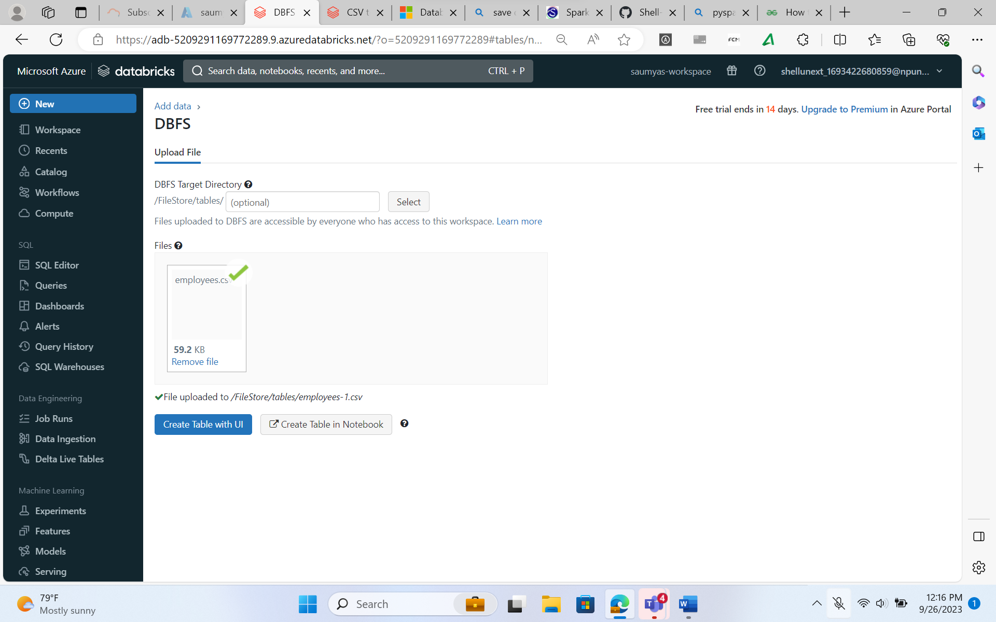

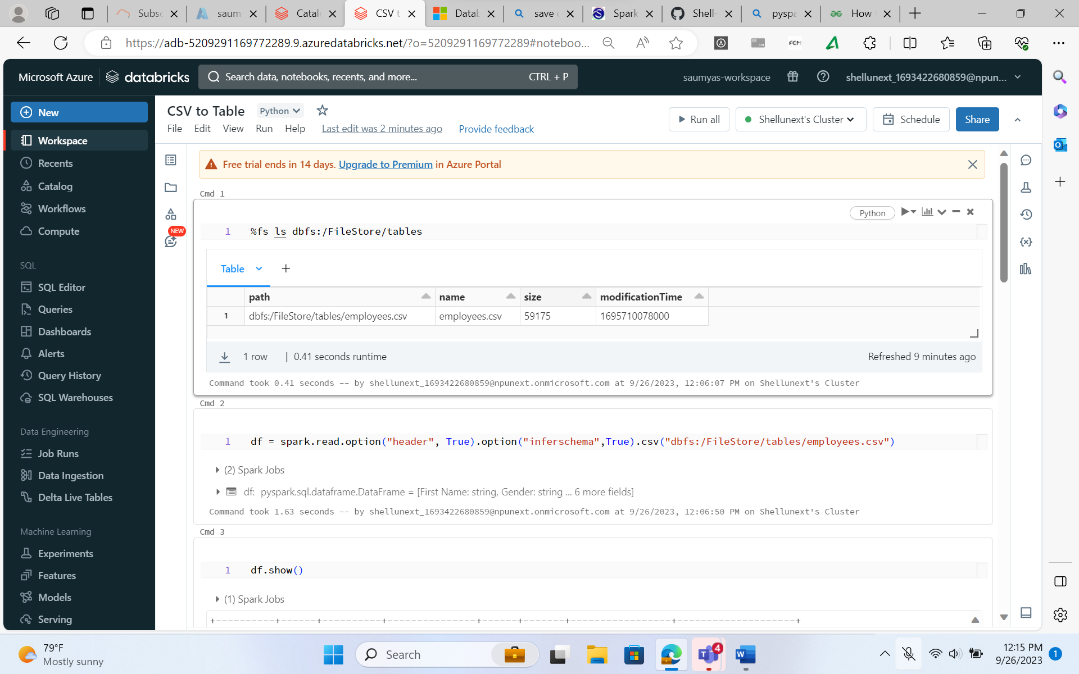

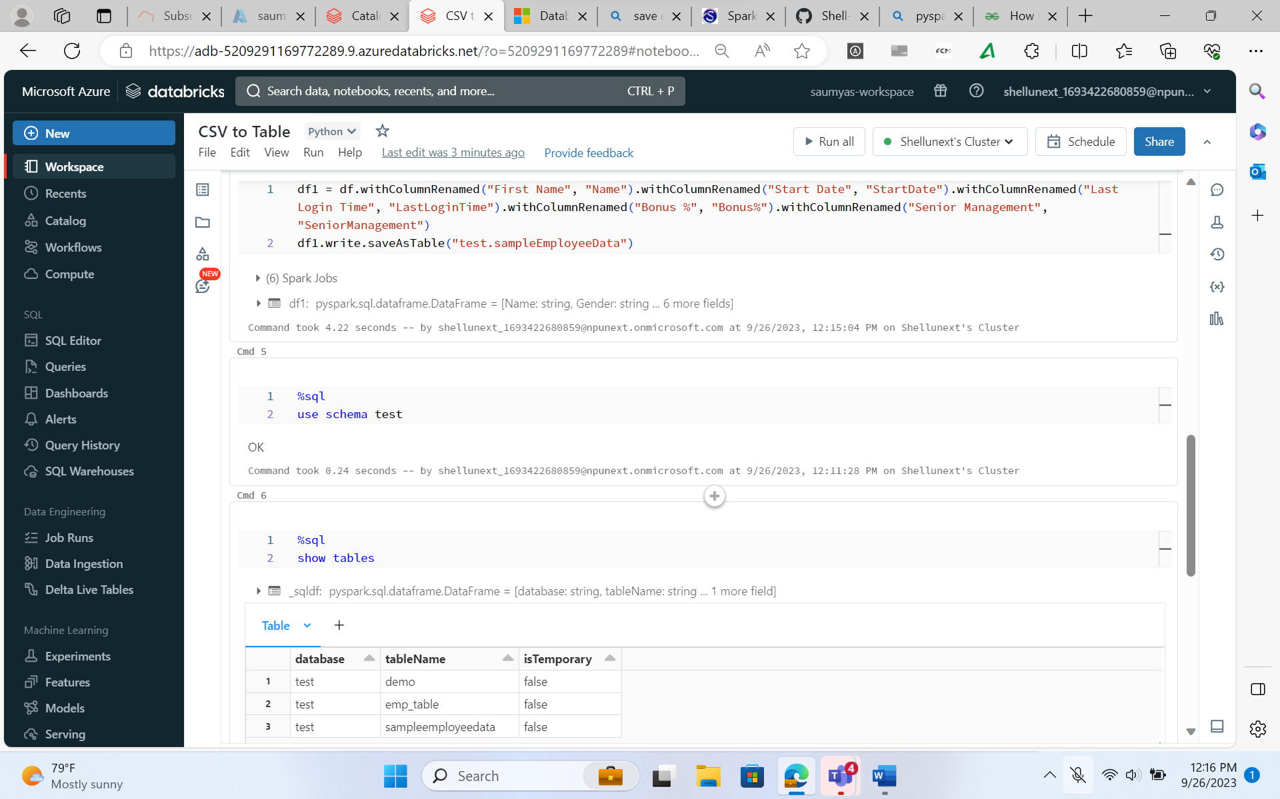

1. **Finding the metadata of the tables which were created:**

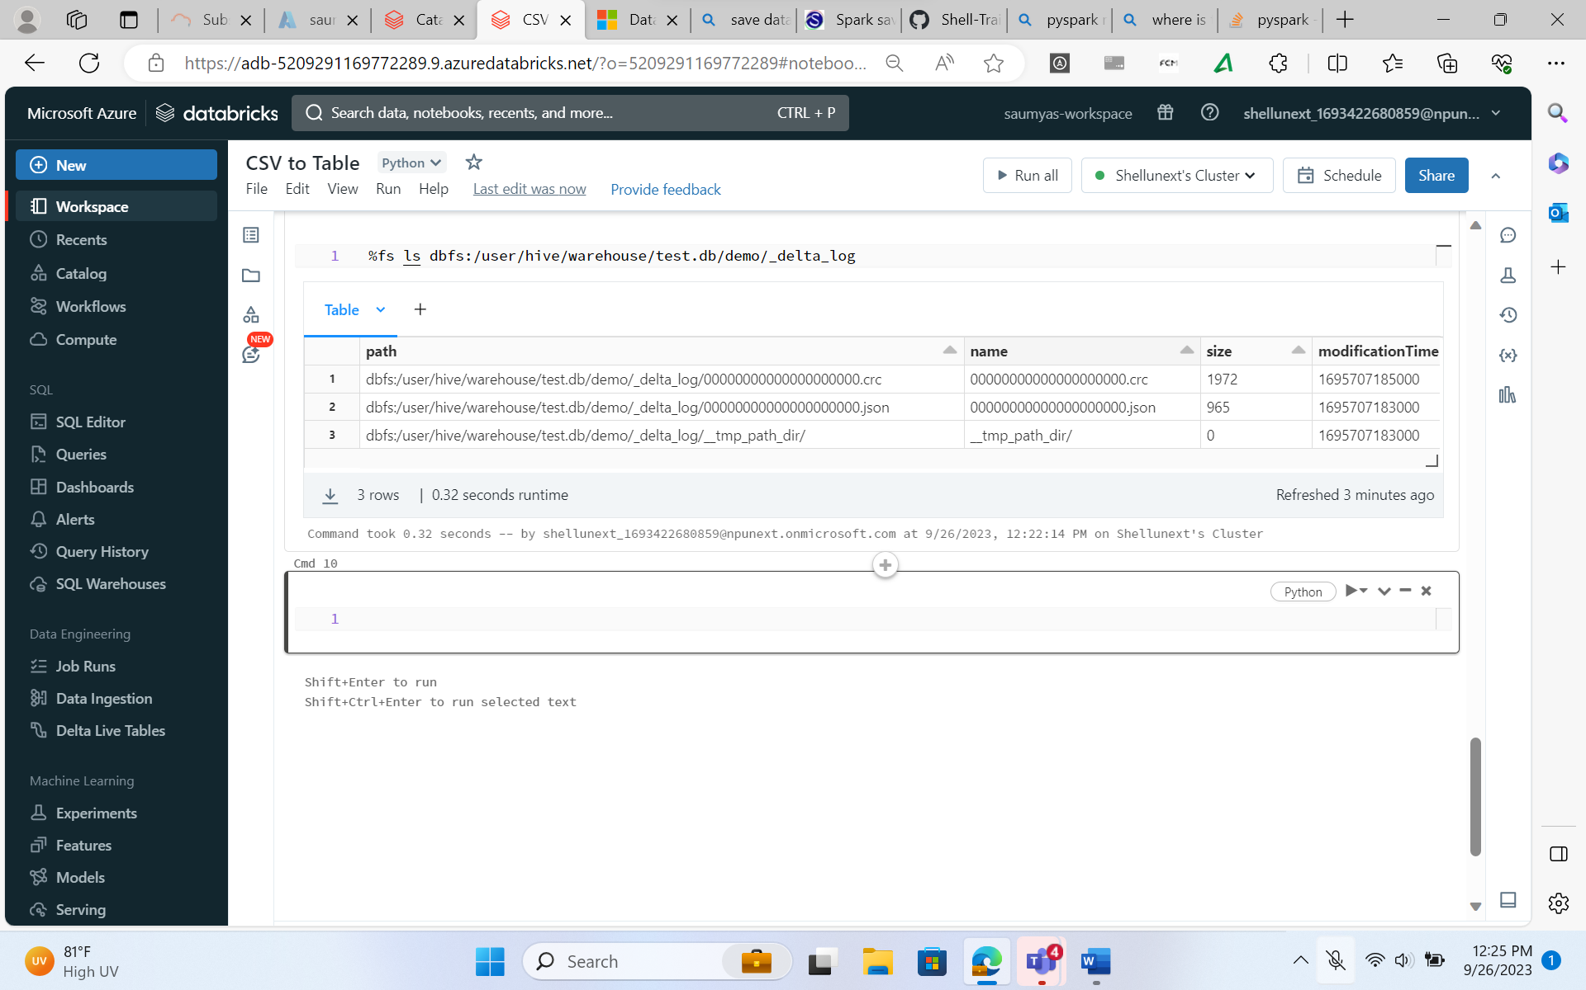

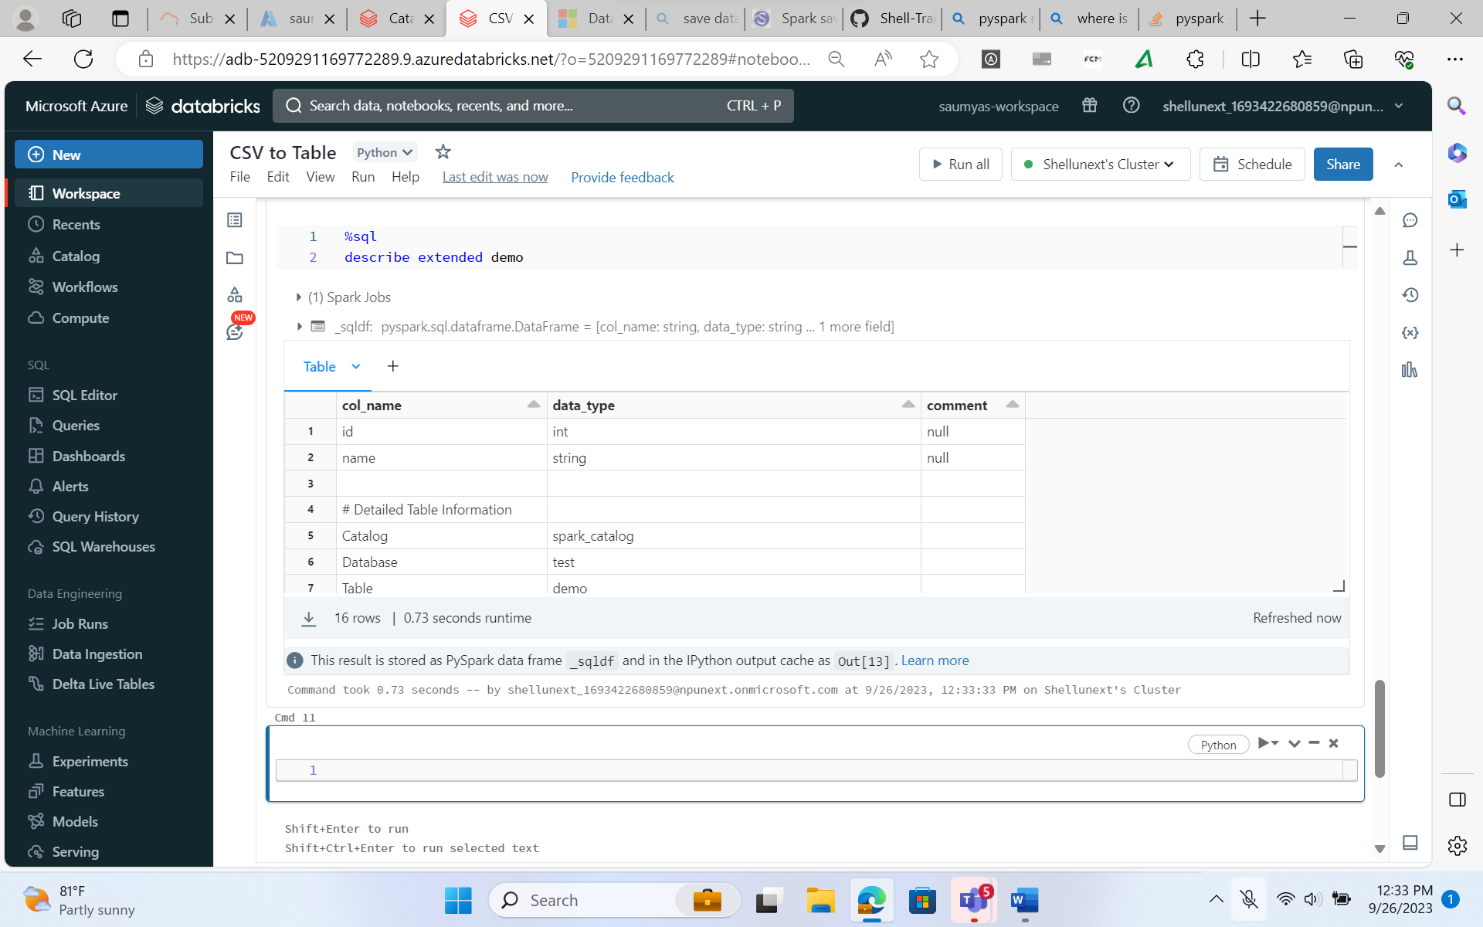

**There are two types of tables in Databricks:**

* **Managed Tables:** Managed by Databricks, handled in DBFS. Metadata will be stored in Databricks.
* **External Tables:** Managed by the cloud providers. Metadata will be stored in the cloud.

1. **How to create a Mount Point in Databricks?**

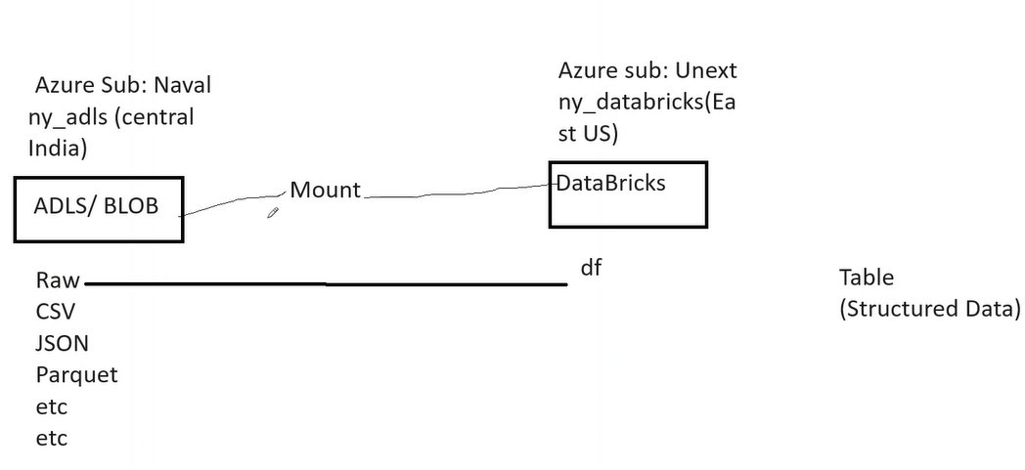

1. **Mounting using Access Keys**

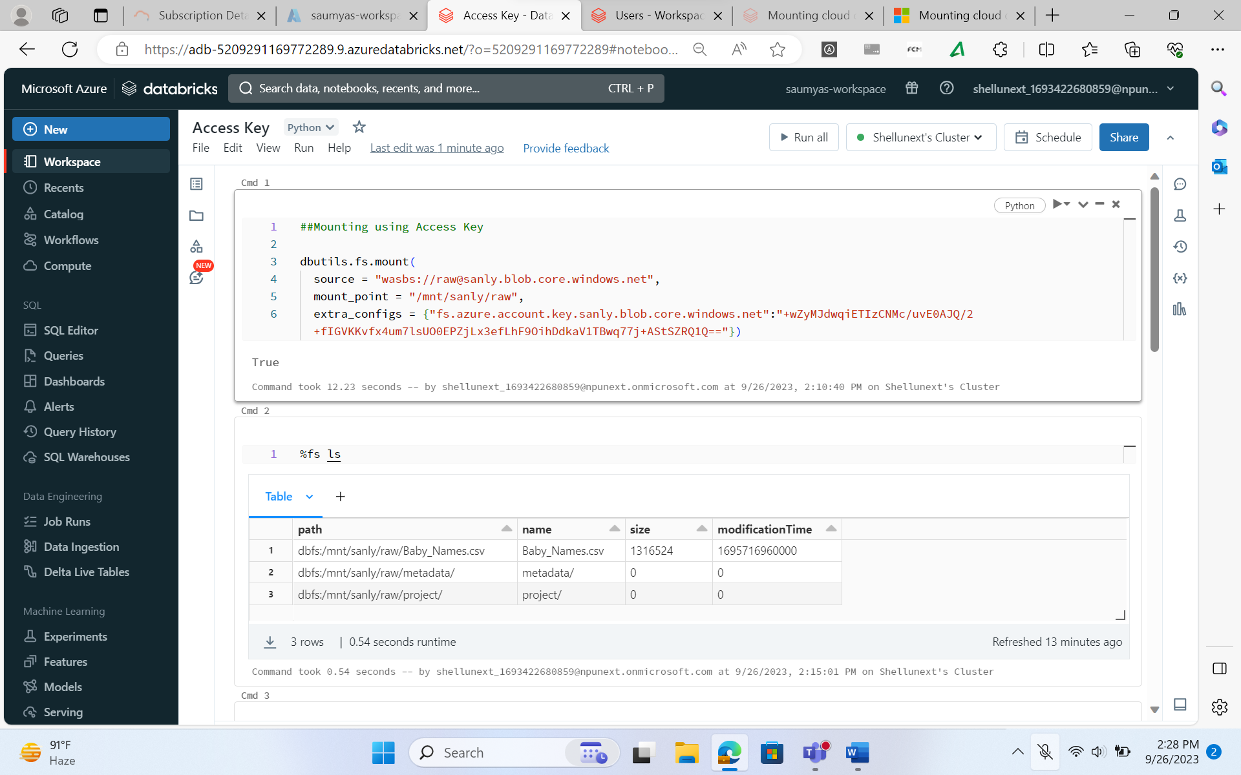

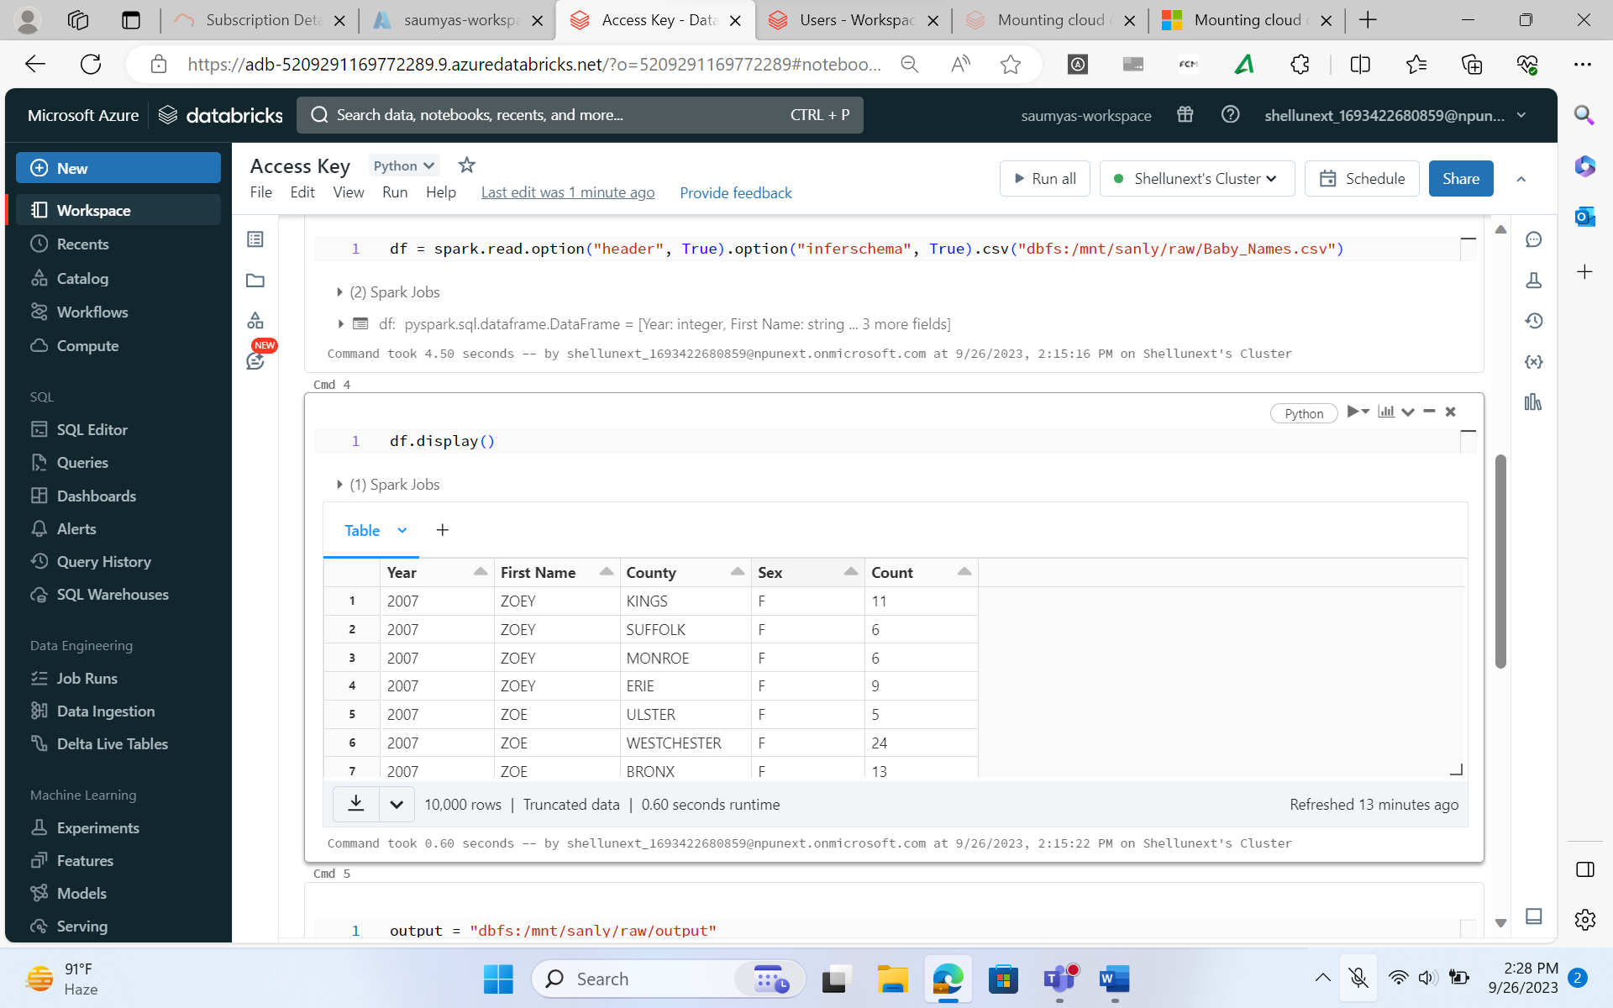

1. **Mounting using SAS Tokens**

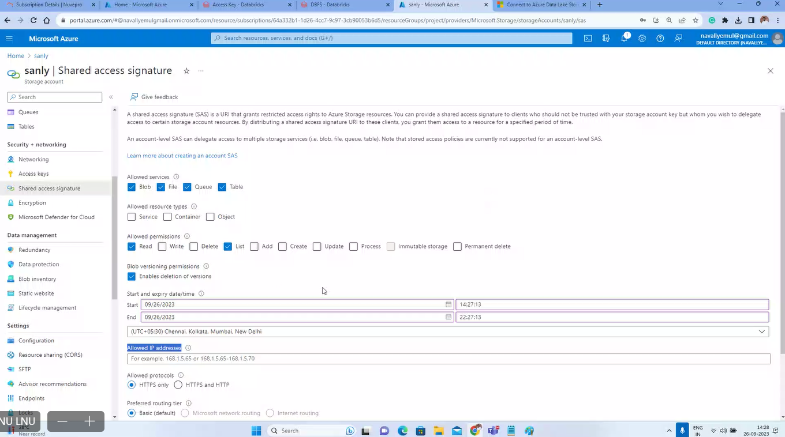

1. **Mounting using Service Principal**

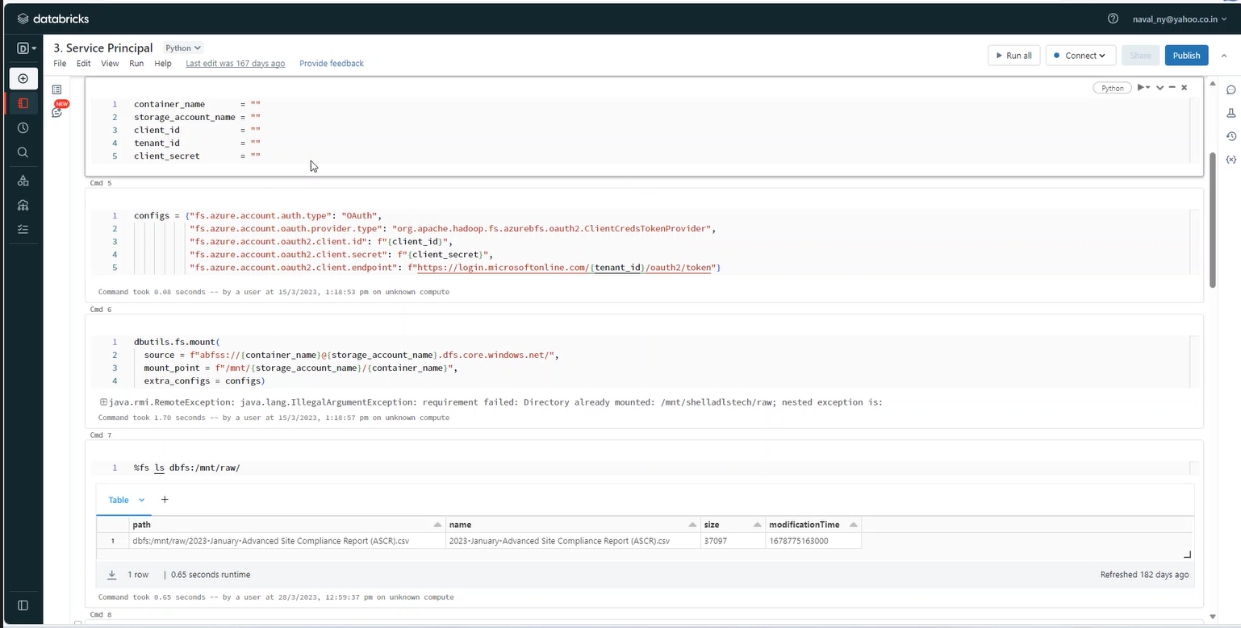

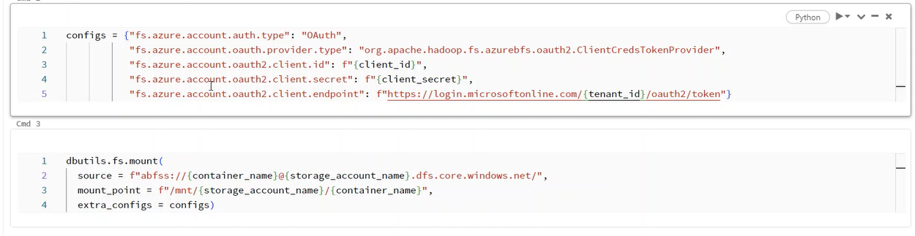

1. **Mounting using Service Principal**

[Tutorial: Connect to Azure Data Lake Storage Gen2 - Azure Databricks | Microsoft Learn](https://learn.microsoft.com/en-us/azure/databricks/getting-started/connect-to-azure-storage)

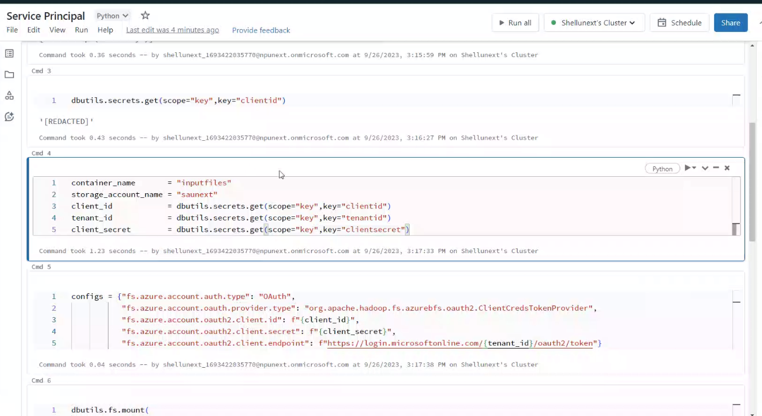

1. **Spark Streaming:**

